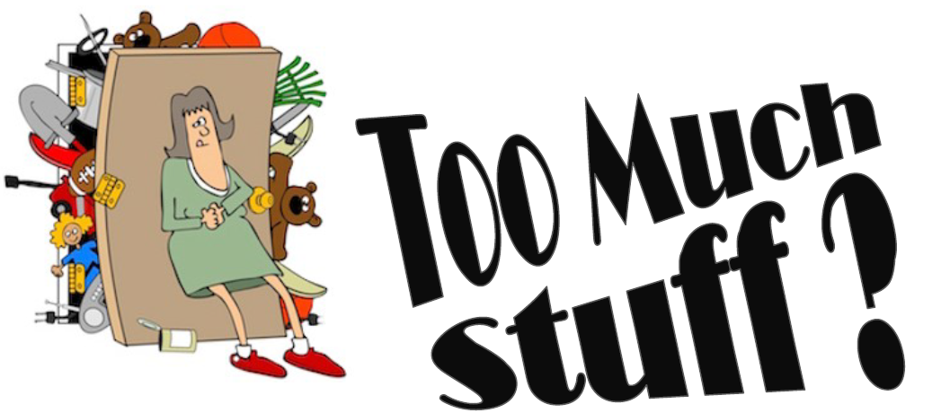

Buy, Sell, Swap, Donate, Pay it Forward

Clothes, Shoes, Jewellery & Accessories, Plants, Household Items, Books, Games and Bric-a-brac
*Sewing Alterations on-site
(Sellers set up from 8 – it’s FREE to have a stall)

SUNDAY 3 November 9-12
Alawa Hall, Lakeside Drive ALAWA
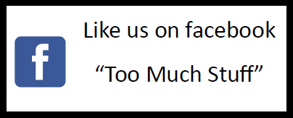
Email esther@uselessplastic.org to register your interest
Too Much Stuff – Darwin’s only recycling, upcycling flea market.
Proudly supported by Charles Darwin University www.cdu.edu.au/sustainability

