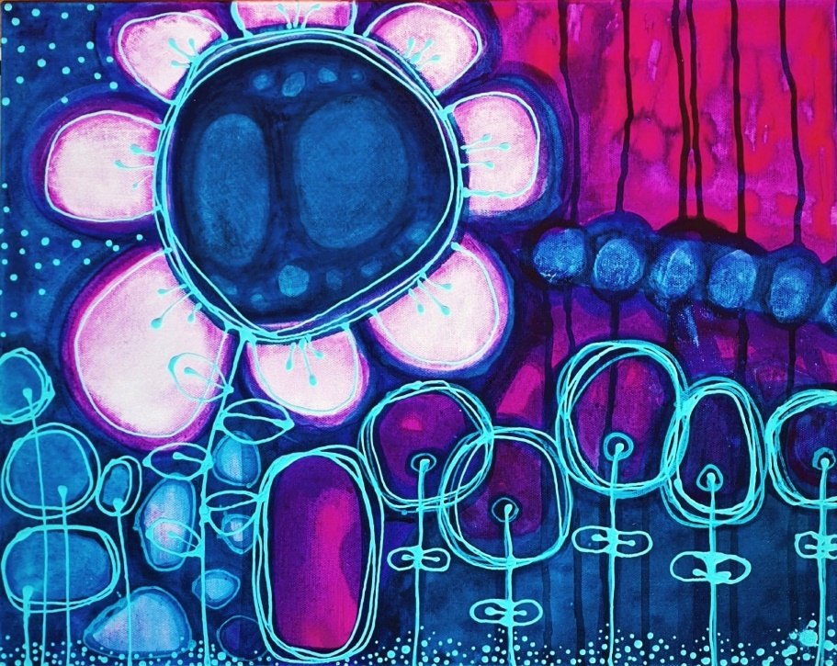
MIXED MEDIA
Art Workshops
by Margie Joy
When ?? :
#1 Saturday 7th MAY
#2 Saturday 14th MAY
What ?? - the fun bits :)
You will Paint, paste, drizzle and doodle onto a Stretched Canvas, using a variety of Mixed media techniques. I will be encouraging you to let yourself go as you create a lovely painting, while I help you to find your own unique style. During the sessions I will be demonstrating and guiding you through different processes, as you create texture with collage and paints and depth with layers of vibrant coloured inks finishing up with mark making and doodling.
You will be: Painting with Acrylic paints, Acrylic Inks & Airbrush Inks.
Doodling using water soluble pencils, fine-line paint applicators and paint pens,
Adding Collage with papers, fabric, serviettes etc.
All classes include use of art equipment, easels, art materials. papers & a canvas.
Please Choose the size canvas you would like to complete to determine if you need to book into a full or half day session.
Option #1: 40x60cm canvas - 1 x 3hr session 9.30 to 12.30pm @ $185
Option #2: 60cm square canvas 1 x 5 hr session 9.30 to 3.30pm @$285 (1 hour lunch)
Option #3: 75cm square canvas 1 x 6 hr session 9.30 to 4.30pm @$325 (1 hour lunch)
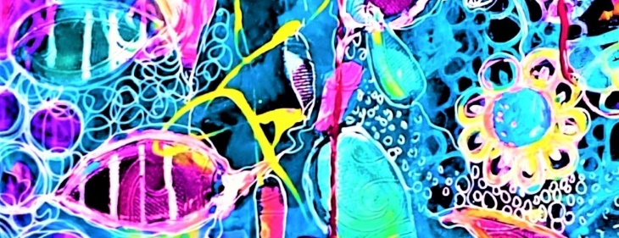
Where?? :
At my Air-conditioned Art Studio/Gallery Shop3, 76 McMinn St Darwin (next door to "The Exhibitionist")
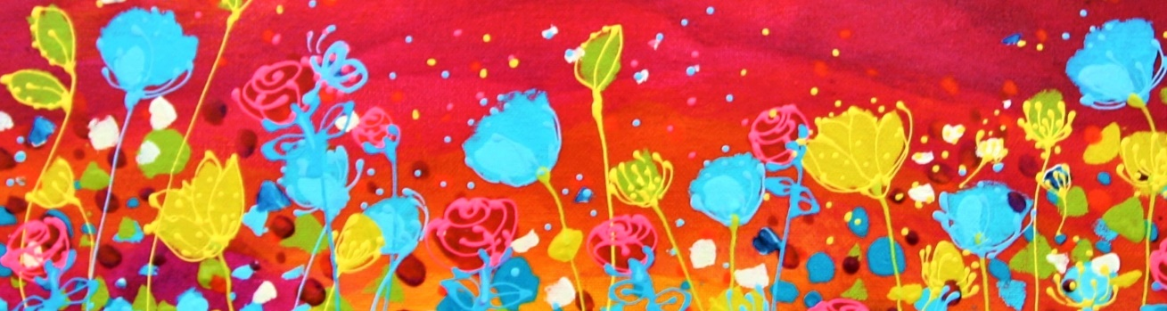
MIXED MEDIA Art Workshops by Margie Joy

Other Bits & pieces of info:
Class sizes will be limited to 4 or 5 Per Session.
Suitable for all levels of experience.
Wear comfy shoes as you may be standing a lot.
Wear old clothing or an apron, be prepared to get a little messy.
How do I Pay? :
When you book I will email you an invoice via my Square App.
The email will include a link so you can pay via debit/credit card or
via bank transfer to secure your space. Square will notify me that the invoice has been paid, then I will lock in your booking.
Send me a text so I can keep an eye out if you do a bank transfer.
Any more questions?? :
Any further questions please send me an email, a text or phone me. My mobile: 0416210624. I look forward to sharing my way of creating joyful expressive art with you.
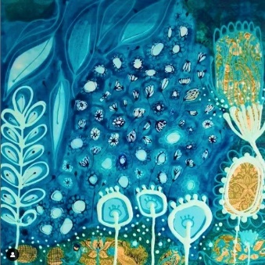
Kind regards from
Margie Joy :)
Mobile 0416210624
follow me on socials @ Margie Joy Creations
email: margiejoycreations@gmail.com

