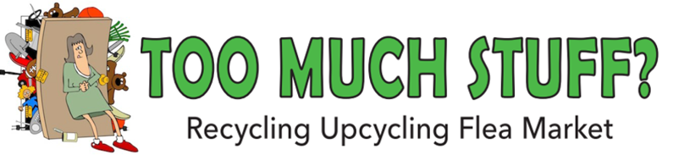

Club Tropical Resort Darwin
Buy, Sell, Swap, Donate, Pay it Forward
Clothes, Shoes, Jewellery & Accessories, Plants, Books, Kids Toys & Games, Fishing, Sporting or Camping Gear, Kitchenware, Household Items and Bric-a-brac, or something else? Fundraising or feeling crafty?
Dedicated Recycling Drop-off point
SUNDAY 25 May 9-12
(Sellers set up from 7am – it’s FREE to have a stall)

Register> Email your name & phone to esther@uselessplastic.org

Too Much Stuff – Darwin’s only recycling, upcycling flea market.
Too Much Stuff, Secondhand Wonderland – City of Darwin Explore
*Finalist in the Sustainable Enterprise Award category of the 2019 NT Natural Resource Management (NRM) Awards

